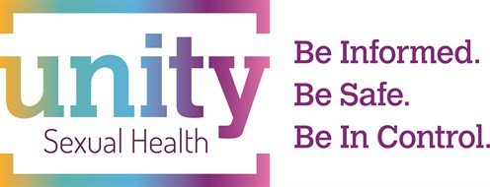
Sexual and Reproductive Health Update

Thursday 11 May 2023

Programme

CHAIR Dr Cindy Farmer, Unity Sexual Health, Central Clinic, Tower Hill, Bristol

09:00 – 09:20 Registration

09:20 – 10.00 Common ambitions update practicalities of PreP, how to record in notes GP involvement in monitoring – Lindsey Harryman

10.00 – 10.40 Update in warts management- Dr Megan Crofts, Unity Sexual Health

10.40 – 11.10 COFFEE

11.10 –11.50 Update in contraception– new IUC guidelines, new POP – Dr Cindy Farmer

11.50 – 12:30 Transgender care with a focus on sexual health – Dr Sarah Cochrane

12:30– 13:30 LUNCH / Sponsors break

13:30 – 14:10 Breakout Session 1
- IUC Workshop – Mrs Emma Trump, Dr Manika Singh, Dr Susanna Hall
- THT - Stigma and Discrimination: understanding and supporting communities
- Brook – Porn, nudes and social networks: Digital issues in young people’s sexual health – Catherine Fahmi
- Contraception for women over 40 – Dr Sharon Moses
- Menopause – Dr Katherine Kearley-Shiers

14:20 – 15:00 Breakout Session 2
- IUC Workshop –Mrs Emma Trump, Dr Manika Singh, Dr Susanna Hall
- THT - Stigma and Discrimination: understanding and supporting communities
- Brook – Porn, nudes and social networks: Digital issues in young people’s sexual health – Catherine Fahmi
- Contraception for women over 40 – Sharon Moses
- Menopause – Dr Katherine Kearley-Shiers

15.00-15.20 COFFEE

15.20– 16:00 Vulval skin condition/ ulcers/ syphilis – Dr Adele Wolujewicz

16.00 -16.40 The buttoned up and the unzipped; challenges in psychosexual medicine – Dr Sally Soodeen

16.45 END

Delegates will be asked to select one topic in breakout Session 1 and one topic from Session 2

